Grade 1: Unit 8 Overview

Number: Partitioning Shapes

Length of Unit: 3-4 weeks

Mathematical Practices (CCSS) |  | Grade Level Focus Areas | Grade Level Domains and Standards
- Make sense of problems and persevere in solving them.  - Reason abstractly and quantitatively.  - Construct viable arguments and critique the reasoning of others.  - Model with mathematics.  - Use appropriate tools strategically.  - Attend to precision.  - Look for and make use of structure.  - Look for and express regularity in repeated reasoning. |  | FA4. Composing & Decomposing Shapes: Reasoning about attributes of, and composing and decomposing geometric shapes | Major Domain: Geometry  Reason with shapes and their attributes.  Supporting Domains: Measurement & Data  Represent and interpret data.
Structural Components  (focusing lens) |  | Explanation  (based on grade level and unit topic)
Shape: Composing and Decomposing |  | Shapes can be decomposed or composed into other shapes. For example, two triangles can make a rectangle.
Shape: Attributes and Properties |  | Shapes are similar or different based on characteristics that include the number of sides and how the sides are related (e.g. length). Shapes can be classified as the same type if they share common characteristics even if they don’t look identical.
Space: Location |  | The orientation and location of a shape in space does not classify the shape but helps when comparing shapes.
Space: Maneuvering |  | Shapes can be re-arranged in space and the path of the transformation can be described using locational and directional words (e.g. above, next to, turn)

Formative Assessment Questions, Tasks, or Examples
Skill/Procedure/Rote | Cover this shape with these other shapes. Now, find another way to cover the shape with other shapes. Use these objects to build another object.
Problem Solving | What is the name for this shape?
Conceptual | What makes these two shapes different?
Reasoning & Justification | Sort these shapes into two groups based on something you think they have that is the same. Tell a partner why you sorted them this way. What does this object (3-D) look like if you pulled apart the shapes (2-D) that make it? Can you draw the shapes (2-D) that make this object (3-D)?

Models
Enactive | Pattern blocks, shape cutouts, 3-D objects (e.g. cubes, pyramids, prisms)
Iconic | Student-created drawings, images of shapes (e.g. shape sorts)
Symbolic | Oral language, written words

Vocabulary
Domain Specific | Shape, square, triangle, rectangle, circle, curve, side, object, cube, pyramid, prism, edge
General | Same, different, longer, shorter, corner, left, right, above, below, turn(ed)

Inclusion Topics
Data Analysis | Sorting and classifying shapes based on student-generated or teacher-directed characteristics.
Patterns | Doubling, halving and quartering.
Measurement | Using linear objects (e.g. edges of cubes, string, straws) to compare lengths of sides and perimeter of various shapes.

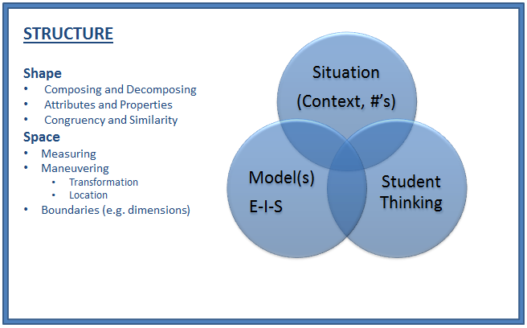
Description of Key Ideas for Learning Goals
There are 2 units in 1st grade that focus on concepts of shape and space. Each unit builds specific understanding and skills related to the topic of geometry with some connections to concepts of measurement and data analysis. In this second unit, the focus continues to be on composing and decomposing shapes and 3-D objects. Students may also be asked to describe the location and arrangement of figures in space with particular attention paid to how the orientation of figures does not change the classification. Students should be asked to examine how shapes are similar or different and demonstrate their ideas through shape sorts with enactive and iconic models. Students must also be given the opportunity to examine how shapes can be composed or decomposed and to describe how a shape may be moved in space (e.g. transformed) but clarify that the defining characteristics of the shape are preserved. Extending student understanding of both 2-D and 3-D figures to compose other figures is a key idea in this unit. To extend students’ previous learning of geometric and measurement concepts, students can be asked to measure attributes of geometric figures using informal tools. There are four specific learning goals for this unit:
- Shapes are named and classified by many characteristics. The number and nature of the sides of a shape is one common classifying feature.
- Shapes can be decomposed into other shapes and can be used to compose other shapes as well.
- Shapes are oriented in space in many ways and the orientation of a shape can be described by the shape’s relationship to other figures or to its original orientation if it is re-arranged (e.g. transformed).
- There is a relationship between 2-D shapes and 3-D solids. Solid objects can be composed/decomposed using 2-D shapes as faces as well as composed from different 3-D solids.

Examples of Models and Situations for Shape and Space
Situation: There are two examples below of similar situations involving either 2-D or 3-D geometric investigations.

2-D: (Use a set of shape cutouts and paddy paper.) “Let’s make this shape with other shapes. Now use the edge of these shapes to measure the outside of the shape. Let’s do this with some other shapes and find which one has the largest measurement around the outside.”

The main standard addressed in unit 8 is partitioning shapes by one-half and one-fourth or one-quarter. This means that each polygon shape is partitioned into equal shares. Students will examine many different ways of partitioning these shapes and will determine which ones do not partition. See examples below: the rhombus, hexagon, rectangle, and square are all partitioned into 4 equal shares, but the parallelogram and the circle are not.

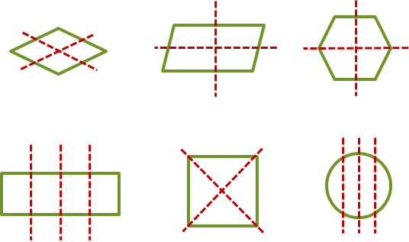

3-D: Solid, three-dimensional, shapes will be examined by their two-dimensional shapes and constructed to create their three-dimensional shape. The shapes below are a rectangular prism, a cube, a cylinder, and a cone. Their properties are examined in regards to whether they roll or stack. Finally, the shapes are composed to construct figures. These figures are used to graph the number of each shape used and the cube is used as a measuring device to determine heights and widths of these different figures.

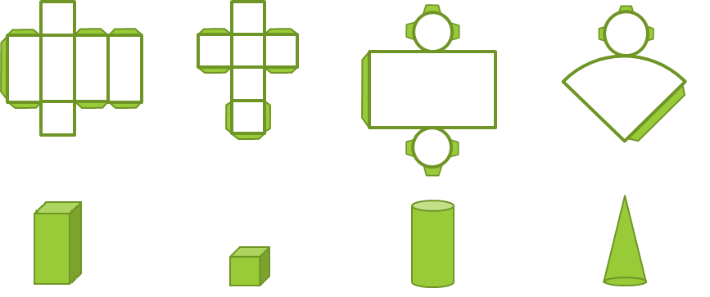

Iconic and Symbolic Models
In this second unit, students are primarily using objects to compose and decompose shapes. They can be asked to use directional and location language (symbolic) to explain how different shapes are moved in space to compose new figures. Whenever possible students should be encouraged to draw (iconic models) the way they have composed or decomposed various figures. Their drawings can be tracings (often with a partner helping to hold the different objects used in the composition) or freehand drawings. Since this is the second time students have been exposed to geometric and measurement situations in this way, students should be encouraged to use both formal oral language and written language to label and describe figures. For example, in a drawing of a cube the student has composed from square face cutouts, the student might be directed to write the words “cube” as a symbolic label for the picture.

Questions:
Which shape/object is longer around/taller? [Skill]

Why does one shape/object have larger measurement than the other? [Concept]

How could you measure the distance around/height of this shape/object without building it first? [Reasoning/Communication]

Note: In the previous 1st grade Composing Shapes and Data unit (Unit 4) focused on composing shapes and examining attributes. In this second unit (Unit 8), students will continue to build on what they were doing in unit 4, but with a focus on partitioning shapes.

During instruction, it is important to draw students’ attention to the attributes of non-polyhedral solids that help classify them such as having circular bases and no distinct edges. One potentially confusing academic vocabulary term that may appear in Unit 8 is “face”. According to most definitions, non-polyhedron have no “faces” because faces must be polygons exclusively. However, this distinction may be cumbersome for young students during initial phases of learning. A more appropriate term for the shapes that make up a non-polyhedron would be “surface”.

Appendix A

Geometry 1.G
K. Reason with shapes and their attributes.
1. Distinguish between defining attributes (e.g., triangles are closed and three-sided) versus non-defining attributes (e.g., color, orientation, overall size); build and draw shapes to possess defining attributes.
2. Compose two-dimensional shapes (rectangles, squares, trapezoids, triangles, half-circles, and quarter-circles) or three-dimensional shapes (cubes, right rectangular prisms, right circular cones, and right circular cylinders) to create a composite shape, and compose new shapes from the composite shape.
3. Partition circles and rectangles into two and four equal shares, describe the shares using the words halves, fourths, and quarters, and use the phrases half of, fourth of, and quarter of. Describe the whole as two of, or four of the shares. Understand for these examples that decomposing into more equal shares creates smaller shares.

Measurement and Data 1.MD
J. Represent and interpret data.
4. Organize, represent, and interpret data with up to three categories; ask and answer questions about the total number of data points, how many in each category, and how many more or less are in one category than in another.

