Grade 1: Unit 7 Overview

Number: Number, Operations and Data

Length of Unit: 3-4 weeks

Mathematical Practices (CCSS) |  |  | Grade Level Focus Areas | Grade Level Domains and Standards (See Appendix A)
- Make sense of problems and persevere in solving them.  - Reason abstractly and quantitatively.  - Construct viable arguments and critique the reasoning of others.  - Model with mathematics.  - Use appropriate tools strategically.  - Attend to precision.  - Look for and make use of structure.  - Look for and express regularity in repeated reasoning. |  |  | FA.1. Addition & Subtraction: Developing understanding of addition, subtraction, and strategies for addition and subtraction within 100  FA.2. Place Value Understanding: Developing understanding of whole number relationships and place value, including grouping in tens and ones | Major Domain: Operations and Algebraic Thinking  Represent and solve problems involving addition and subtraction  Understand and apply properties of operations and the relationship between addition and subtraction Add and subtract within 100  Work with addition and subtraction equations  Supporting Domains: Number and Operations in Base Ten and Measurement  Use place value understanding and properties of operations to add and subtract.  Represent and interpret data.
Structural Components  (focusing lens) | Explanation  (based on grade level and unit topic)
Units and Unitizing | The unit of one and ten is used to count both forward and backwards. Units of hundreds are composed of 10 units of ten or 100 units of one.
Composing and Decomposing | The ability to put objects together and then break them apart while still retaining numbers’ quantities and relative sizes.
Partitioning and Iterating | The ability to copy a unit of the same size or measure over and over again or split it up into equivalent units.
Equivalence and Relationships | Understanding how numbers or quantities are related to one another.

Formative Assessment Questions, Tasks, or Examples
Skill/Procedure/Rote |  | Which number is larger 34 or 43? What about 79 or 91?
Problem Solving |  | Students in this unit will solve all problem types: join, separate, part-whole, and compare.
Conceptual |  | Using 10’s and 1’s, explain which number is larger 23 or 32 and by how much?
Reasoning & Justification |  | Tom says that he can use a 10’s rod only to determine which number is largest. He says, “For 23, I need two 10’s and for 32, I need three 10’s. So, 32 is larger.” Will his strategy always work?

Models
Enactive |  | Cubes, paper strips, rods
Iconic |  | Bar model, number line
Symbolic |  | Tree diagram, equations/number sentences, partial sums

Vocabulary
Domain Specific |  | Units, sum, difference, expanded form, word form, standard form, tree diagram, addend, bar model, digit, partial sums, commutative property, associative property, decompose, compose, inverse operations, equation
General |  | Count up (count on), count back, skip count, equal (same as), less than, greater than, place value, ones, tens, hundreds, place value strategy, making 10, making 100.

Inclusion Topics
Data Analysis |  | Create a survey where students must use a bar graph to generate compare problems with numbers in the teens and twenties.  Generate questions related to the survey.  Make predictions from the data to another similar situation.
Patterns |  | Focus on counting by units of 10, 5, and 1.
Fluency Development |  | Students should practice addition and subtraction flexibility by using the following strategies (doubles when appropriate, making the next ten, and place value).

Description of Key Ideas for Learning Goals
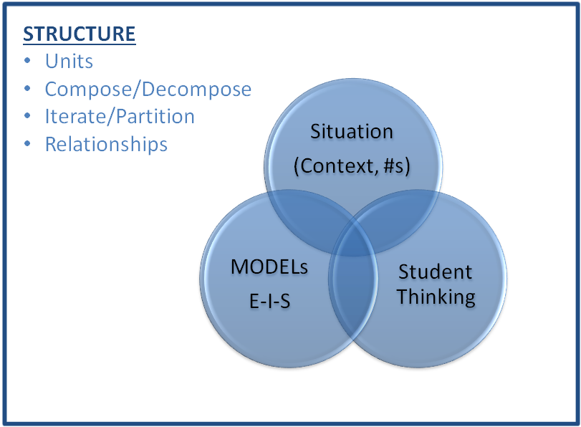
There are four units in Grade 1 that focus on number, counting, number operations, and place value. Each unit builds specific skills within the topic of number. In this fourth unit on number the focus is on adding and subtracting using part-whole, compare, join and separate problem types (with numbers up to 100); representing the different situations using enactive iconic and symbolic models; and applying the commutative and associate properties. The key ideas for this unit are:
The key ideas for this unit are:
- The quantity one is the unit size of one or a measure of one; the quantity ten is its own unit, which is composed of ten units of size one; the quantity one hundred is a unit composed of 10 units of size 10 and 100 units of size 1.
- Commutative property (decomposing and composing): the sum of adding two numbers is the same no matter the order, a + b = b + a
- Associative property (decomposing and composing): the sum of adding three or more numbers is the same no matter the grouping or ordering of any two addends, (a + b) + c = a + (b + c)
- Equivalence (relationships): The equal sign is used to represent two equal amounts and the quantities on both sides represent “the same” amount. For instance, 3 + 4 represents the same amount as 5 + 2 even though the sum of 7 is composed differently.

Examples of Models and Situations
Situation: Rachel collected __ silly bands and Isabel collected __ silly bands. Who collected the most silly bands? How many more silly bands did she collect? (8, 14) (32, 15) (45, 31) (86, 67)

Enactive Model example

Use 10 units and 1 units (paper strips or rods and singles) to construct the first two problems.

(8, 14) (32, 15)
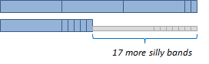
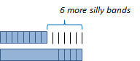

Iconic Model examples
Draw bar models (with a number line below) to represent the amount of silly bands each girl has, who has the most, and by how much. Be as precise as possible. Example with (8, 14)

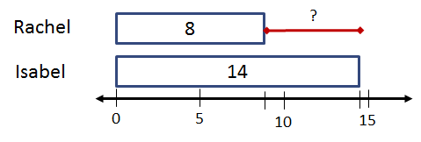

Symbolic Model example(s)
Use the tree diagram to solve the problem. Then, write a number sentence that matches the context. What is a second number sentence that works, but might not match the context?

(8, 14) (32, 15)

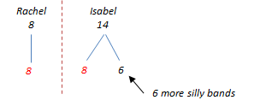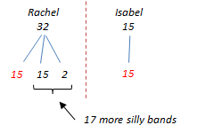

8 + □ = 14 or 14 – 8 = □ 15 + □ = 32 or 32 – 15 = □

How many more silly bands does Isabel have than Rachel?

Questions:
- How do the bars actually represent 32 and 15?
- Using 10 as the unit, show on the bar models where these units are? (e.g, 10, 20, etc)
- How many silly bands do the girls have altogether? Show this on a number line.
- Why did one student decompose Rachel’s 32 into a 15 + 15 + 2? Would there be another way? Which is more efficient?

Possible Fluency Topics
Card Game
Beth and Jill are playing cards. Each card is worth its face value. Jacks are worth 11, Queens 12, and Kings 13. They each get 3 cards. They add up their cards and the winner is the player with largest amount. Keep track of how many times you win.

Extension 1: Try the game above by dealing out 5 cards each or 7 cards.
Extension 2: If Beth said she has 26, what cards might she have had with 3 cards? (Make a table of all possibilities)

There are additional fluency tasks and activities in the Unit 7 module as well as the addition and subtraction fact fluency supplemental modules.

Appendix A

Operations and Algebraic Thinking 1.OA
A. Represent and solve problems involving addition and subtraction.
1. Use addition and subtraction within 20 to solve word problems involving situations of adding to, taking from, putting together, taking apart, and comparing, with unknowns in all positions, e.g., by using objects, drawings, and equations with a symbol for the unknown number to represent the problem.
2. Solve word problems that call for addition of three whole numbers whose sum is less than or equal to 20, e.g., by using objects, drawings, and equations with a symbol for the unknown number to represent the problem.
B. Understand and apply properties of operations and the relationship between addition and subtraction.
3. Apply properties of operations as strategies to add and subtract. Examples: If 8 + 3 = 11 is known, then 3 + 8 = 11 is also known. (Commutative property of addition.) To add 2 + 6 + 4, the second two numbers can be added to make a ten, so 2 + 6 + 4 = 2 + 10 = 12. (Associative property of addition.)
4. Understand subtraction as an unknown-addend problem. For example, subtract 10 – 8 by finding the number that makes 10 when added to 8.
C. Add and subtract within 20.
5. Relate counting to addition and subtraction (e.g., by counting on 2 to add 2).
6. Add and subtract within 20, demonstrating fluency for addition and subtraction within 10. Use strategies such as counting on; making ten (e.g., 8 + 6 = 8 + 2 + 4 = 10 + 4 = 14); decomposing a number leading to a ten (e.g., 13 – 4 = 13 – 3 – 1 = 10 – 1 = 9); using the relationship between addition and subtraction (e.g., knowing that 8 + 4 = 12, one knows 12 – 8 = 4); and creating equivalent but easier or known sums (e.g., adding 6 + 7 by creating the known equivalent 6 + 6 + 1 = 12 + 1 = 13).
D. Work with addition and subtraction equations.
7. The equal sign, and determine if equations involving addition and subtraction are true or false. For example, which of the following equations are true and which are false? 6 = 6, 7 = 8 – 1, 5 + 2 = 2 + 5, 4 + 1 = 5 + 2.
8. Determine the unknown whole number in an addition or subtraction equation relating to three whole numbers. For example, determine the unknown number that makes the equation true in each of the equations 8 + ? = 11, 5 = _ – 3, 6 + 6 = _.

Number and Operations in Base Ten 1.NBT
G. Use place value understanding and properties of operations to add and subtract.
4. Add within 100, including adding a two-digit number and a one-digit number, and adding a two-digit number and a multiple of 10, using concrete models or drawings and strategies based on place value, properties of operations, and/or the relationship between addition and subtraction; relate the strategy to a written method and explain the reasoning used. Understand that in adding two-digit numbers, one adds tens and tens, ones and ones; and sometimes it is necessary to compose a ten.
5. Given a two-digit number, mentally find 10 more or 10 less than the number, without having to count; explain the reasoning used.
6. Subtract multiples of 10 in the range 10-90 from multiples of 10 in the range 10-90 (positive or zero differences), using concrete models or drawings and strategies based on place value, properties of operations, and/or the relationship between addition and subtraction; relate the strategy to a written method and explain the reasoning used.

Measurement and Data 1.MD
J. Represent and interpret data.
4. Organize, represent, and interpret data with up to three categories; ask and answer questions about the total number of data points, how many in each category, and how many more or less are in one category than in another.

