Grade 1: Unit 6 Overview

Number: Measurement iteration and time

Length of Unit: 3-4 weeks

Mathematical Practices (CCSS) | Grade Level Focus Areas | Grade Level Domains and Standards (See Appendix A)
- Make sense of problems and persevere in solving them.  - Reason abstractly and quantitatively.  - Construct viable arguments and critique the reasoning of others.  - Model with mathematics.  - Use appropriate tools strategically.  - Attend to precision.  - Look for and make use of structure.  - Look for and express regularity in repeated reasoning. | FA.3. Informal Linear Measurement: Developing understanding of linear measurement and measuring lengths as iterating length units | Major Domain: Measurement & Data  Measure lengths indirectly and by iterating length units.  Tell and write time.  Supporting Domains: Number and Operations in Base Ten, Operations & Algebraic Thinking
Structural Components  (focusing lens) | Explanation  (based on grade level and unit topic)
Units and Unitizing | Different units are used to make measurement comparisons. The unit is determined by the attribute measured (e.g. length). Smaller units of measure will result in a larger measurement. Ten units of 1 can be collected and renamed as one unit of 10. Units of time have a connection to linear measurement but are organized into a system different than Base 10.
Partitioning and Iterating | Units must be iterated with no gaps or overlaps so that the measureable attribute is accurately measured and comparable.
Zero | When beginning a measurement, the counted units begin at “0” until an entire unit is iterated.
Transitivity and Conservation | Both qualitative and quantitative comparisons can be made through transitive reasoning and an understanding of the conservation of particular attributes.

Formative Assessment Questions, Tasks, or Examples
Skill/Procedure/Rote | Which pencil is longer? Which table is the tallest if you use these paper strips to measure their height? Is this time (hour hand shown on a clock) closer to 1:00 or 2:00?
Problem Solving | If your friend thought this pencil was 15 units long, but you knew it was 16 units long, how do you think your friend decided it was only 15 units long?  If you have 32 units, how many units of 10 and 1 can you have?
Conceptual | Show how long all of these objects are on a number line by laying them end to end and showing the tens and ones.
Reasoning & Justification | Measure the height of all of the students in your group (of 3-5 students) with blocks. Draw the stacks of blocks to show how tall each person is. What is the difference in height from the tallest to shortest person in your group?

Models
Enactive |  | Blocks, cubes, lengths of string, paper strips, paper clips, straws, physical clocks with moveable hour hands (no minute hands)
Iconic |  | Number lines, student-created drawings and simple bar graphs and pictographs, analog clocks with no minute hand
Symbolic |  | Oral language, written labels and numbers (primarily on number lines and informal rulers)

Vocabulary
Domain Specific |  | Unit, length, weight, size, height, difference, number line, hour, o’clock
General |  | Compare, measure, gaps, overlaps, tools , larger, bigger, smaller, taller, shorter, heavier, lighter, half, longer

Inclusion Topics
Data Analysis |  | Constructing simple bar graphs (as free-hand or traced drawings) to show attributes such as length as measured with cubes or blocks.
Patterns |  | Beginning all counted measurements with 0. Jumping by units of 10 and 1 on the number line. Noting that the clock measures time from 12 to 1 and then begins at 12 again in a circular fashion.
Fluency Development |  | Developing the counting sequence by using counting as part of the process of measuring attributes. Begin skip counting sequences on numbers other than 0. For example, “Let’s count by 10 but start on 3. Now let’s count back down to 3.”
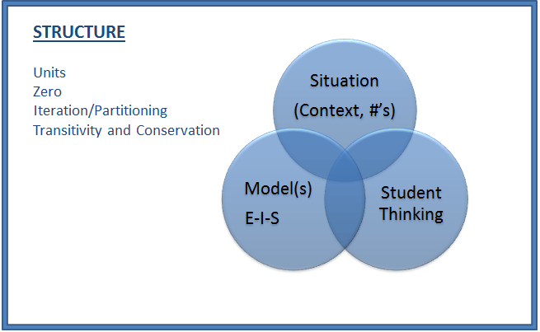

Description of Key Ideas for Learning Goals
There are two units in 1st grade that focus on measurement and data topics. Each unit will build specific skills within the topic of measurement, primarily, but will have connections to data analysis topics and will be used as a context to develop understanding of the Base 10 number system. In this second unit, the focus is on making more complex linear measurements, making more specific connections to the Base 10 number system and a broad conceptual understanding of time as an attribute similar to linear measurement. Students should predominantly use informal tools and units (e.g. paper strips, cubes). Students must then be encouraged to make quantitative comparisons between measurements as a context for solving addition and subtraction problems and using the number line as a model for communicating and reasoning:
- Measuring is an act of making comparisons. To make physical comparisons, measurements will either be between an object and a unit or between different objects’ attributes.
- When counting units of measure, the measurement begins at “0” regardless of where the measurement begins on the object.
- To accurately measure physical attributes, no gaps or overlaps can occur during iterations of the unit of measure.
- Length is the measure from one point to another and requires a unit that is continuous.

Examples of Models and Situations for Measurement Iteration
(Connecting linear measurement to measurement of time)
Situation: “Draw a number line from 1:00 to 2:00. Show where you think this time is by placing a mark between 1:00 and 2:00. Then mark a new time on your number line and show it on the clock.”

Enactive and Iconic Model example
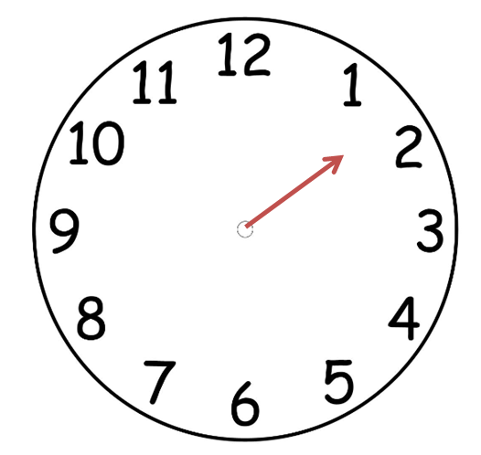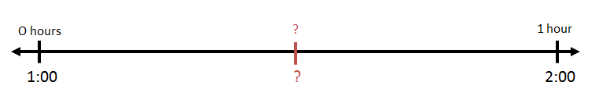

*It is important to use a “Double” number line that is labeled with both the time and the portion of an hour associated with that time. In situations in which students are examining times between 12:00 and 1:00, not labeling the number line this way will result in the potentially confusing placement of 12 before 1 on the number line.

**Note that the minute hand is absent in these models. Students are examining the linear measure of an hour at this grade level and will eventually learn to use the minute hand in later grades.

Symbolic and Iconic Models example(s)
In this second unit, students continue formalizing their conceptions of linear measurement, making comparisons, and connecting their measurements to the Base 10 number system. Students should now be encouraged to count linear measurements in units of 10 and units of 1 and describe these measurements in both oral and written language. For example, an object measuring 32 units in length can be described as “32 units in length” and also “3 units of ten and 2 units of one in length.” This unit also introduces measurements of time. It is critical that students make connections between the continuous nature of linear measurement and time as this will allow them to eventually use the x-axis on the coordinate grid in later grades as a representation of elapsed time. The Double Number Line will become a useful tool if it is associated with analog clocks using only the hour hand. The minute hand should be implied and introduced only when students have demonstrated a depth of understanding of increments of hours.

Questions/Tasks:
What name would you give the time shown on the clock? [Skill]

If each hour (from 1:00 to 2:00) is 60 minutes, how many minutes do you think are shown on the clock? [Concept]

If your friend said that the time was 2:00, how would you explain that it was not 2:00? Can you use your clock and number line to explain your answer? [Reasoning/Communication]

Appendix A

Measurement and Data 1.MD
H. Measure lengths indirectly and by iterating length units.
1. Order three objects by length; compare the lengths of two objects indirectly by using a third object.
2. Express the length of an object as a whole number of length units, by laying multiple copies of a shorter object (the length unit) end to end; understand that the length measurement of an object is the number of same-size length units that span it with no gaps or overlaps. Limit to contexts where the object being measured is spanned by a whole number of length units with no gaps or overlaps.
I. Tell and write time.
3. Tell and write time in hours and half-hours using analog and digital clocks.

