Grade 1: Unit 5 Overview

number (Join and Separate) and place value

Length of Unit: 3 – 4 weeks

Mathematical Practices (CCSS) |  | Grade Level Focus Areas | Grade Level Domains and Standards
- Make sense of problems and persevere in solving them.  - Reason abstractly and quantitatively.  - Construct viable arguments and critique the reasoning of others.  - Model with mathematics.  - Use appropriate tools strategically.  - Attend to precision.  - Look for and make use of structure.  - Look for and express regularity in repeated reasoning. |  | FA.1. Addition & Subtraction: Developing understanding of addition, subtraction, and strategies for addition and subtraction within 20  FA.2. Place Value Understanding: Developing understanding of whole number relationships and place value, including grouping in tens and ones | Major Domain: Number and Operations in Base Ten  Supporting Domains: Operations and Algebraic Thinking  Focus on building place value understanding (1.NBT.b), e.g., discuss 12 is 12 ones and 1 ten and 2 ones (different size units); Addition & subtraction within 20 using context (1.OA.a-d)  1.NBT.b Understand place value  1.OA.a Represent and solve problems involving addition and subtraction  1.OA.b Understand and apply properties of operations and the relationship between addition and subtraction  1.OA.c Add and subtract within 20  1.OA.d Work with addition and subtraction equations
Structural Components (focusing lens) |  | Explanation (based on grade level and unit topic)
Unit/Unitizing |  | The unit of one and ten is used to count both forward and backwards.
Compose and Decompose |  | The ability to put objects together and then break them apart while still retaining numbers’ quantities and relative sizes.
Iterate and Partition |  | The ability to copy a unit of the same size or measure over and over again or split it up into equivalent units.
Relationship |  | Understanding how numbers or quantities are related to one another

Formative Assessment Questions, Tasks, or Examples
Skill/Procedure/Rote | Write the number 35.  Show me the number 58.  Count to 42 starting at 10 and then count backwards from 42 to 31.  Which number is greater, 49 or 51?
Problem Solving | Building on previous learning of static problem types (e.g. part whole and compare) students should solve active problem types (e.g. joining and separating). Students should have developed familiarity with joining and separating problems in kindergarten. Extensions to situations in which the joined or separated set is unknown can be addressed.  E.g., 25 bunnies sat on the grass. 7 of the bunnies left. How many bunnies are still on the grass? (Separate Result Unknown)  E.g., 25 bunnies were sitting on the grass and then some bunnies hopped over to join them. If there are 31 bunnies on the grass now, how many bunnies hopped onto the grass? (Join Change Unknown)
Conceptual | How many tens do you need to make this number if you can only use tens and ones? What is another way to use tens and ones to compose the number?  Use a model to show the sum of 18 + 15.
Reasoning & Justification | A student says that the number sentence 18 + 25 = ? matches the problem below. Use a model to help you explain why this is not correct and then write the correct number sentence and solve the problem.  There were 18 kids in the gym. At lunch some more kids came to play in the gym. Now there are 25 kids in the gym. How many kids came to play at lunch?

Models
Enactive | Cubes, manipulatives, ten frames, Rekenrek
Iconic | Drawing of cubes, bar model, number line
Symbolic | Numbers, number sentences, tree diagram, 2-column t-chart

Vocabulary
Domain Specific | Count, forward, backwards, more, less, add, subtract, bar model, number line, digit, decompose, and compose
General | Equal (same as), less than, greater than, place value, units of ones and tens, groups, compare

Inclusion Topics
Data Analysis | Create a bar graph representing the different types of shoes (buckles, ties, neither)
Patterns | Students should focus on number patterns when adding 10 to different numbers. Ask, what is staying the same and what is changing.
Fluency Development | Students should see smaller numbers within larger numbers (visually), e.g., 6 is made up of a 3 and 3 or a 2, 2, and 2.  Basic fact fluency can be developed with a focus on flexibility and number relationships, particularly using doubles and make 10 combinations (e.g. 5 + 6 = 5 + 5 + 1 or 6 + 6 – 1).

Description of Key Ideas for Learning Goals
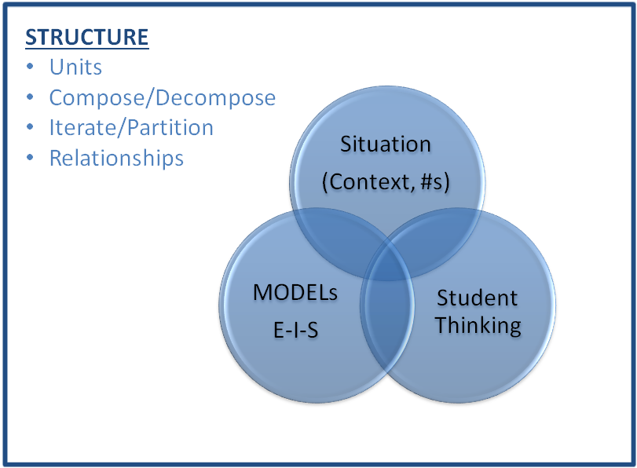
There are four units in grade 1 that focus on number, counting, number operations, and place value. Each unit builds specific skills within the topic of number. In this third unit on number the focus is on adding and subtracting using join and separate problem types (with numbers up to 100); representing the different situations using enactive, iconic and symbolic models; and applying the commutative and associate properties. The key ideas for this unit are:
- The quantity one is the unit size of one or a measure of one.
- The quantity ten is its own unit, which is composed of ten units of size one.
- Students count numbers forward and backwards, counting each object one time in sequence (one-to-one to correspondence)
- Commutative property: the sum of adding two numbers is the same no matter the order, a + b = b + a
- Associative property: the sum of adding three or more numbers is the same no matter the grouping or ordering of any two addends, (a + b) + c = a + (b + c)
- Equivalence: The equal sign is used to represent two equal amounts and the quantities on both sides represent “the same” amount. For instance, 3 + 4 represents the same amount as 5 + 2 even though the sum of 7 is composed differently.

Examples of Models and Situations

Situations:
Note: The additional number sets provided after each problem are intended to replace the original numbers in the problem to increase the problem’s difficulty and to offer more place value connections. Some of the extension number sets would have been too difficult in the past for Grade 1 students, but most of these number sets should appropriate for students at the time of year Unit 5 is addressed.

Jack had 8 toy cars. Jack was given 15 more toy cars. How many toy cars does Jack have now? (12, 15) (17, 19) (29, 13) [Join Result Unknown]

Jack had 8 toy cars. Jack was given some more toy cars. Now Jack has 23 toy cars. How many toy cars was Jack given? (12, 27) (7, 37) (3, 29) [Join Change Unknown Problem Type]

Jack had 18 toy cars. Jack gave 3 to a friend. How many toy cars does he have now? (25, 12) (27, 9), (24, 15) [Separate Result Unknown]

Jack had 8 toy cars. He gave some to a friend. Now he has 5 toy cars. How many did he give away? (18, 7), (24,18), (29, 8) [Separate Change Unknown]

Enactive Model
Students can represent situations with cubes or counters just as they have in previous Grade 1 units. However, beginning with this unit (Unit 5) the emphasis should be on using the enactive models to ensure the iconic (visual) models students construct are proportional and accurately represent the problems being solved.

Iconic Model (Number line and bar model examples)
Situation: Jack had 18 toy cars. Jack was given some more toy cars. Now Jack has 23 toy cars. How many toy cars was Jack given? Model or represent the situation with a bar model and then solve the situation using the number line. [Join Change Unknown]
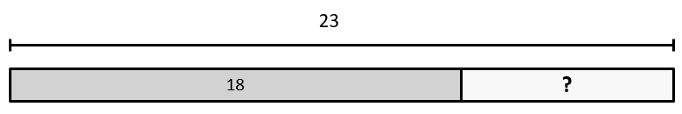

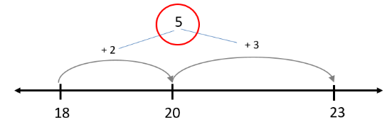

One of your classmates thought that to solve the problem you needed to add 18 + 23. Use your models to help explain why that is incorrect. [Reasoning and Justification]

Symbolic Model
18 + ? = 23 18 + T = 23 18 + ___ = 23 23 = 18 + ? 23 = 18 + T 23 = 18 + ____

Fluency Development
In this unit students begin to work towards becoming fluent with both basic addition and subtraction facts as well as smaller two-digit addition and subtraction problems. For basic fact development, an emphasis on using the anchor fact strategies of Doubles and Make 10 are given ample attention. Place value methods (18 + 13 = 10 + 10 + 8 +3) as well as a Make the Next Ten (Unit) strategies (18 + 13 = 18 + 2 + 1 + 10) are addressed.

Appendix A: CCSS-Mathematics

Operations and Algebraic Thinking 1.OA
A. Represent and solve problems involving addition and subtraction.
1. Use addition and subtraction within 20 to solve word problems involving situations of adding to, taking from, putting together, taking apart, and comparing, with unknowns in all positions, e.g., by using objects, drawings, and equations with a symbol for the unknown number to represent the problem.
2. Solve word problems that call for addition of three whole numbers whose sum is less than or equal to 20, e.g., by using objects, drawings, and equations with a symbol for the unknown number to represent the problem.
B. Understand and apply properties of operations and the relationship between addition and subtraction.
3. Apply properties of operations as strategies to add and subtract. Examples: If 8 + 3 = 11 is known, then 3 + 8 = 11 is also known. (Commutative property of addition.) To add 2 + 6 + 4, the second two numbers can be added to make a ten, so 2 + 6 + 4 = 2 + 10 = 12. (Associative property of addition.)
4. Understand subtraction as an unknown-addend problem. For example, subtract 10 – 8 by finding the number that makes 10 when added to 8.
C. Add and subtract within 20.
5. Relate counting to addition and subtraction (e.g., by counting on 2 to add 2).
6. Add and subtract within 20, demonstrating fluency for addition and subtraction within 10. Use strategies such as counting on; making ten (e.g., 8 + 6 = 8 + 2 + 4 = 10 + 4 = 14); decomposing a number leading to a ten (e.g., 13 – 4 = 13 – 3 – 1 = 10 – 1 = 9); using the relationship between addition and subtraction (e.g., knowing that 8 + 4 = 12, one knows 12 – 8 = 4); and creating equivalent but easier or known sums (e.g., adding 6 + 7 by creating the known equivalent 6 + 6 + 1 = 12 + 1 = 13).
D. Work with addition and subtraction equations.
7. The equal sign, and determine if equations involving addition and subtraction are true or false. For example, which of the following equations are true and which are false? 6 = 6, 7 = 8 – 1, 5 + 2 = 2 + 5, 4 + 1 = 5 + 2.
8. Determine the unknown whole number in an addition or subtraction equation relating to three whole numbers. For example, determine the unknown number that makes the equation true in each of the equations 8 + ? = 11, 5 = _ – 3, 6 + 6 = _.

Number and Operations in Base Ten 1.NBT
F. Understand place value.
2. Understand that the two digits of a two-digit number represent amounts of tens and ones. Understand the following as special cases:
a. 10 can be thought of as a bundle of ten ones — called a “ten.”
b. The numbers from 11 to 19 are composed of a ten and one, two, three, four, five, six, seven, eight, or nine ones.
c. The numbers 10, 20, 30, 40, 50, 60, 70, 80, 90 refer to one, two, three, four, five, six, seven, eight, or nine tens (and 0 ones).
3. Compare two two-digit numbers based on meanings of the tens and ones digits, recording the results of comparisons with the symbols >, =, and <.

