Grade 1: Unit 4 Overview

Number: Composing Shapes and Space

Length of Unit: 3-4 weeks

Mathematical Practices (CCSS) |  | Grade Level Focus Areas | Grade Level Domains and Standards
- Make sense of problems and persevere in solving them.  - Reason abstractly and quantitatively.  - Construct viable arguments and critique the reasoning of others.  - Model with mathematics.  - Use appropriate tools strategically.  - Attend to precision.  - Look for and make use of structure.  - Look for and express regularity in repeated reasoning. |  | FA4. Composing & Decomposing Shapes: Reasoning about attributes of, and composing and decomposing geometric shapes | Major Domain: Geometry  Reason with shapes and their attributes.  Supporting Domains: Measurement & Data  Represent and interpret data.
Structural Components  (focusing lens) |  | Explanation  (based on grade level and unit topic)
Shape: Composing and Decomposing |  | Shapes can be decomposed or composed into other shapes. For example, two triangles can make a rectangle.
Shape: Attributes and Properties |  | Shapes are similar or different based on characteristics that include the number of sides and how the sides are related (e.g. length). Shapes can be classified as the same type if they share common characteristics even if they don’t look identical.
Space: Location |  | The orientation and location of a shape in space does not classify the shape but helps when comparing shapes.
Space: Maneuvering |  | Shapes can be re-arranged in space and the path of the transformation can be described using locational and directional words (e.g. above, next to, turn)

Formative Assessment Questions, Tasks, or Examples
Skill/Procedure/Rote | What is the name for this shape?
Problem Solving | Cover this shape with these other shapes. Now, find another way to cover the shape with other shapes. Use these objects to build another object.
Conceptual | What makes these two shapes different?
Reasoning & Justification | Sort these shapes into two groups based on something you think they have that is the same. Tell a partner why you sorted them this way. What does this object (3-D) look like if you pulled apart the shapes (2-D) that make it? Can you draw the shapes (2-D) that make this object (3-D)?

Models
Enactive | Pattern blocks, shape cutouts, 3-D objects (e.g. cubes, pyramids, prisms)
Iconic | Student-created drawings, images of shapes (e.g. shape sorts)
Symbolic | Oral language, written words

Vocabulary
Domain Specific | Shape, square, triangle, rectangle, circle, curve, side, object, cube, pyramid, prism
General | Same, different, longer, shorter, corner, left, right, above, below, turn(ed)

Inclusion Topics
Data Analysis | Sorting and classifying shapes based on student-generated or teacher-directed characteristics.
Patterns | Examine the relationship between shapes. .
Measurement | Using linear objects (e.g. edges of cubes, string, straws) to compare lengths of sides and perimeter of various shapes.

Description of Key Ideas for Learning Goals
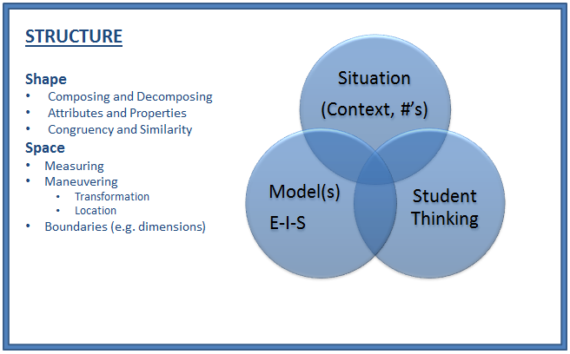
There are 2 units in 1st grade that focus on concepts of shape and space. Each unit builds specific understanding and skills related to the topic of geometry with some connections to concepts of measurement and data analysis. In this first unit, the focus is on composing and decomposing shapes and 3-D objects. Students may also be asked to describe the location and arrangement of figures in space with particular attention paid to how the orientation of figures does not change the classification. Students should be asked to examine how shapes are similar or different and demonstrate their ideas through shape sorts with enactive and iconic models. Students must also be given the opportunity to examine how shapes can be composed or decomposed and to describe how a shape may be moved in space (e.g. transformed) but clarify that the defining characteristics of the shape are preserved. Using both 2-D and 3-D figures to compose other figures is a critical experience in this unit. There are four specific learning goals for this unit:
- Shapes are named and classified by many characteristics. The number and nature of the sides of a shape is one common classifying feature.
- Shapes can be decomposed into other shapes and can be used to compose other shapes as well.
- Shapes are oriented in space in many ways and the orientation of a shape can be described by the shape’s relationship to other figures or to its original orientation if it is re-arranged (e.g. transformed).
- There is a relationship between 2-D shapes and 3-D solids. Solid objects can be composed/decomposed using 2-D shapes as faces as well as composed from different 3-D solids.

Examples of Models and Situations focusing on Shape and Space
Situation: There are two examples below of similar situations involving either 2-D or 3-D geometric investigations.
2-D: (using a set of shape cutouts or pattern blocks) “Let’s find how to make this (shape, picture) with these other shapes. Can you find different ways?”
3-D: (using a paper net for any regular pyramid, prism, cube, or tetrahedron) “Let’s cut out this collection of shapes connected together and fold them to make a new object. What can you say about the shapes used to make the solid object and how they make the solid object look after you folded it together? How would you describe the solid object to a friend over the phone?”

Enactive Model example
2-D

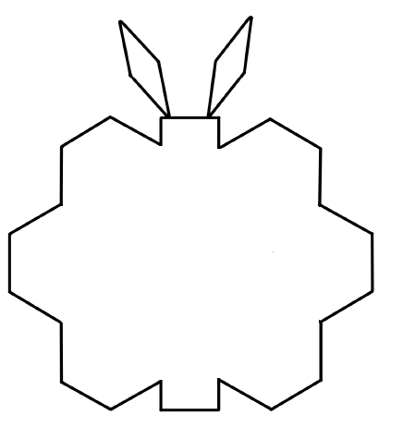
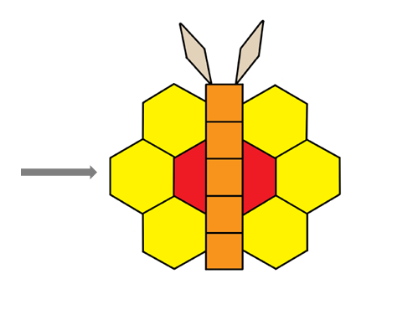

3-D
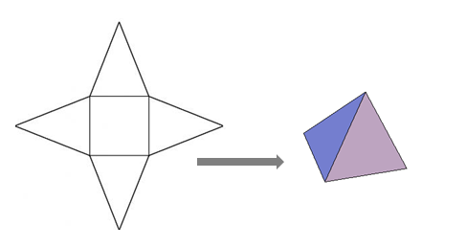
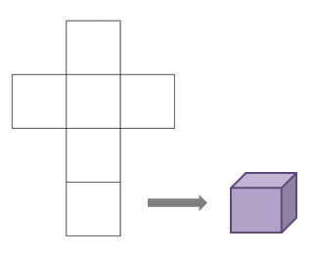

Iconic and Symbolic Models
For this first unit, students are primarily using objects to compose and decompose shapes. They can be asked to use directional and location language (symbolic) to explain how different shapes are moved in space to compose new figures. Whenever possible students should be encouraged to draw (iconic models) the way they have composed or decomposed various figures. Their drawings can be tracings (often with a partner helping to hold the different objects used in the composition) or freehand drawings. If applicable, students can begin to use written words as labels for shapes or parts of compositions. For example, in a drawing of a cube the student has composed from square face cutouts, the student might be directed to write the words “cube” as a symbolic label for the picture.

Questions:

How many (shape, squares, hexagons, etc.) did you use? [Skill]
Find another way to make the (shape, picture, solid object) with different (pattern blocks, shapes, objects) [Concept]
Make a shape (or solid object) of your own and then draw what it looks like for a friend. Help them build the same shape. [Reasoning/Communication]

Note: A key distinction between the experiences of students in kindergarten and those in 1st grade in this first shape and space unit is that 3-D solids are examined as a collection of 2-D shapes in 1st grade earlier in the year than in kindergarten. Because this is the first shape and space unit and it occurs relatively early in the year, it is ideal to begin instruction with investigations focusing on polyhedron (pyramids, prisms, cubes, etc.) and avoid analyzing cones and cylinders. Examinations of cones and cylinders can occur later in the year as students expand their understanding of 3-D geometry. Confusion and misconceptions can occur if students try to apply what they know about polyhedron to non-polyhedral solids (cones and cylinders) as these solids do not have the same characteristics as polyhedron (e.g. faces, vertices, edges).

Appendix A

Geometry 1.G
K. Reason with shapes and their attributes.
1. Distinguish between defining attributes (e.g., triangles are closed and three-sided) versus non-defining attributes (e.g., color, orientation, overall size); build and draw shapes to possess defining attributes.
2. Compose two-dimensional shapes (rectangles, squares, trapezoids, triangles, half-circles, and quarter-circles) or three-dimensional shapes (cubes, right rectangular prisms, right circular cones, and right circular cylinders) to create a composite shape, and compose new shapes from the composite shape.

Measurement and Data 1.MD
J. Represent and interpret data.
4. Organize, represent, and interpret data with up to three categories; ask and answer questions about the total number of data points, how many in each category, and how many more or less are in one category than in another.

