Grade 1: Unit 3 Overview

Number: Part Whole and Compare Problems and Place Value

Length of Unit: 3-4 weeks

Mathematical Practices (CCSS) |  | Grade Level Focus Areas | Grade Level Domains and Standards (See Appendix A)
- Make sense of problems and persevere in solving them.  - Reason abstractly and quantitatively.  - Construct viable arguments and critique the reasoning of others.  - Model with mathematics.  - Use appropriate tools strategically.  - Attend to precision.  - Look for and make use of structure.  - Look for and express regularity in repeated reasoning. |  | FA.1. Addition & Subtraction: Developing understanding of addition, subtraction, and strategies for addition and subtraction within 20  FA.2. Place Value Understanding: Developing understanding of whole number relationships and place value, including grouping in tens and ones | Major Domain: Number and Operations in Base Ten  Understand place value  Supporting Domains: Operations and Algebraic Thinking  Represent and solve problems involving addition and  subtraction  Understand and apply properties of operations and the  relationship between addition and subtraction  Add and subtract within 20  Work with addition and subtraction equations
Structural Components  (focusing lens) |  | Explanation  (based on grade level and unit topic)
Units and Unitizing |  | The unit of one and ten is used to count both forward and backwards.
Composing and Decomposing |  | The ability to put objects together and then break them apart while still retaining numbers’ quantities and relative sizes.
Partitioning and Iterating |  | The ability to copy a unit of the same size or measure over and over again or split it up into equivalent units.
Equivalence and Relationships |  | Understanding how numbers or quantities are related to one another

Formative Assessment Questions, Tasks, or Examples
Skill/Procedure/Rote | Write the number 25.  Show me the number 38.  Count to 32 starting at 10 and then count backwards from 32 to 20.  Which number is greater, 29 or 31?
Problem Solving | Building on previous learning of active problem types (e.g. joining and separating) students should solve part-whole and compare contextual problems.  E.g., 15 bunnies sat on the grass. 7 of the bunnies have spots and the rest do not. How many bunnies do not have spots? (Part Whole: Part Unknown)  E.g., 12 bunnies were sitting on the grass and 7 bunnies were in a cage. How many more bunnies are on the grass than in the cage? (Compare Difference Unknown)
Conceptual | How many tens do you need to make this number if you can only use tens and ones? What is another way to use tens and ones to compose the number?  Use a model to show the sum of 18 + 5.
Reasoning & Justification | A student claims the sum of 18 + 5 is 68. Use a model to show why this is incorrect and explain what the correct sum should be.

Models
Enactive | Cubes, manipulatives, ten frames, Rekenrek
Iconic | Drawing of cubes, bar model, number line
Symbolic | Numbers, number sentences, tree diagram, 2-column t-chart

Vocabulary
Domain Specific | Count, forward, backwards, more, less, add, subtract, bar model, number line, digit, decompose, and compose
General | Equal (same as), less than, greater than, place value, units of ones and tens, groups, compare

Inclusion Topics
Data Analysis | Create a bar graph representing the different types of shoes (buckles, ties, neither)
Patterns | Counting forwards and backwards
Fluency Development | Students should see smaller numbers within larger numbers (visually), e.g., 6 is made up of a 3 and 3 or a 2, 2, and 2.  Basic fact fluency can be developed with a focus on flexibility and number relationships, particularly using doubles and make 10 combinations (e.g. 5 + 6 = 5 + 5 + 1 or 6 + 6 – 1).

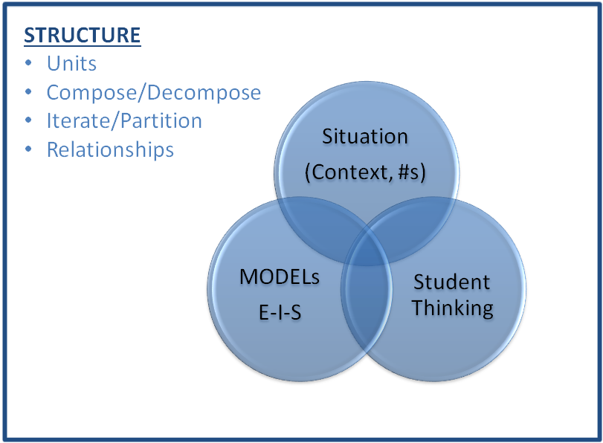
Description of Key Ideas for Learning Goals
There are four units in Grade 1 that focus on number, counting, number operations, and place value. Each unit builds specific skills within the topic of number. In this second unit on number the focus is on adding and subtracting using part-whole and compare problem types (with numbers at least up to 20); representing the different situations using enactive iconic and symbolic models; and applying the commutative and associate properties. The key ideas for this unit are:
- The quantity one is the unit size of one or a measure of one.
- The quantity ten is its own unit, which is composed of ten units of size one.
- Students count numbers forward and backwards, counting each object one time in sequence (one-to-one to correspondence)
- Commutative property: the sum of adding two numbers is the same no matter the order, a + b = b + a
- Associative property: the sum of adding three or more numbers is the same no matter the grouping or ordering of any two addends, (a + b) + c = a + (b + c)
- Equivalence: The equal sign is used to represent two equal amounts and the quantities on both sides represent “the same” amount. For instance, 3 + 4 represents the same amount as 5 + 2 even though the sum of 7 is composed differently.

Examples of Models and Situations
Situations:
- Jack collected 13 toy cars. If 8 of the cars were black and the rest were red, how many cars were red? (Part Whole: Part Unknown) [Problem Solving]

- Jack collected 13 toy cars. Dan collected 8 toy cars. How many more cars does Jack have than Dan? (Compare Difference Unknown) [Problem Solving]

Enactive Model example
Modeling the situations with cubes or counters.
(Part B from above)
Note: This enactive model example of B from above presents the bar models built with cubes as being laid horizontally next to one another. Students will first be introduced to vertical comparison bar models in the associated module as young children often find it easier to make comparisons focused on, “…how much taller?” one set is from another before they are comfortable with answering the more general, “…how many more?” question. This example is provided to demonstrate what students will ultimately do with compare problems and models.
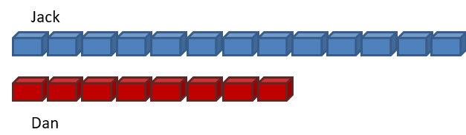

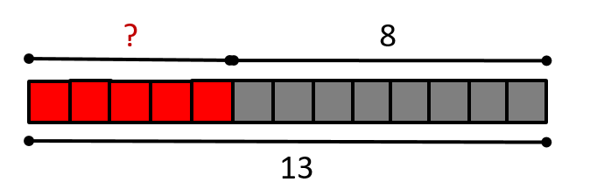
Iconic Model examples
Draw a bar model to represent the problem. [Concept]
(Part A from above)

Symbolic Model example(s)
Students should model situations using bar models and number lines (or informal pictures in some cases) as previously shown and then connect these models to the symbolic notation used to represent the situation.

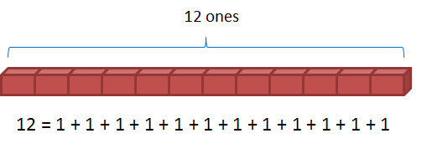
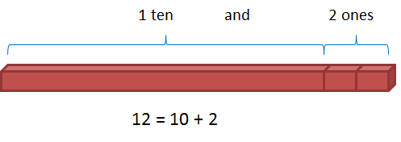
Questions/Place Value Situations:
Students should use the models and numbers to represent quantities using units of one and units of ten. Ask students about place value in relation to the ones and tens units. For example, the number 12 represents 12 units of size 1 or 1 unit of size 10 and 2 units of size one. This idea is represented below both iconically and symbolically. Have students create representations for teen numbers and up to at least 25 (ideally extending to numbers larger than 25 for many students).

Patterns: Ask students to look for patterns between the numbers n and (10 + n) (e.g., 3 and 13 or 6 and 16). One activity would be for students to either build with cubes or with a bar model the matching numbers 0 and 10, 1 and 11, 2 and 12, . . . 10 and 20.

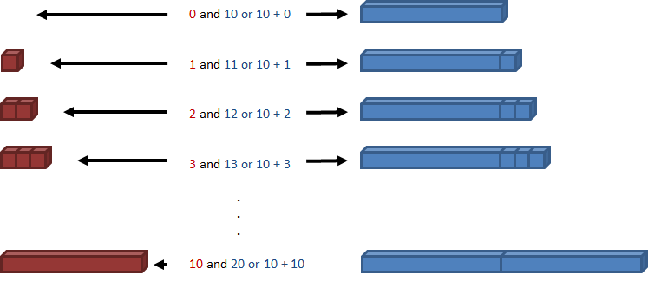

Appendix A

Number and Operations in Base Ten 1.NBT
E. Extend the counting sequence.
1. Count to 120, starting at any number less than 120. In this range, read and write numerals and represent a number of objects with a written numeral.
F. Understand place value.
2. Understand that the two digits of a two-digit number represent amounts of tens and ones. Understand the following as special cases:
a. 10 can be thought of as a bundle of ten ones — called a “ten.”

Operations and Algebraic Thinking 1.OA
A. Represent and solve problems involving addition and subtraction.
1. Use addition and subtraction within 20 to solve word problems involving situations of adding to, taking from, putting together, taking apart, and comparing, with unknowns in all positions, e.g., by using objects, drawings, and equations with a symbol for the unknown number to represent the problem.
2. Solve word problems that call for addition of three whole numbers whose sum is less than or equal to 20, e.g., by using objects, drawings, and equations with a symbol for the unknown number to represent the problem.
B. Understand and apply properties of operations and the relationship between addition and subtraction.
3. Apply properties of operations as strategies to add and subtract. Examples: If 8 + 3 = 11 is known, then 3 + 8 = 11 is also known. (Commutative property of addition.) To add 2 + 6 + 4, the second two numbers can be added to make a ten, so 2 + 6 + 4 = 2 + 10 = 12. (Associative property of addition.)
4. Understand subtraction as an unknown-addend problem. For example, subtract 10 – 8 by finding the number that makes 10 when added to 8.
C. Add and subtract within 20.
5. Relate counting to addition and subtraction (e.g., by counting on 2 to add 2).
6. Add and subtract within 20, demonstrating fluency for addition and subtraction within 10. Use strategies such as counting on; making ten (e.g., 8 + 6 = 8 + 2 + 4 = 10 + 4 = 14); decomposing a number leading to a ten (e.g., 13 – 4 = 13 – 3 – 1 = 10 – 1 = 9); using the relationship between addition and subtraction (e.g., knowing that 8 + 4 = 12, one knows 12 – 8 = 4); and creating equivalent but easier or known sums (e.g., adding 6 + 7 by creating the known equivalent 6 + 6 + 1 = 12 + 1 = 13).
D. Work with addition and subtraction equations.
7. The equal sign, and determine if equations involving addition and subtraction are true or false. For example, which of the following equations are true and which are false? 6 = 6, 7 = 8 – 1, 5 + 2 = 2 + 5, 4 + 1 = 5 + 2.
8. Determine the unknown whole number in an addition or subtraction equation relating to three whole numbers. For example, determine the unknown number that makes the equation true in each of the equations 8 + ? = 11, 5 = _ – 3, 6 + 6 = _.

