Grade 1: Unit 2 Overview

Informal Linear Measurement through Iteration

Length of Unit: 3-4 weeks

Mathematical Practices (CCSS) |  | Grade Level Focus Areas | Grade Level Domains and Standards (See Appendix A)
- Make sense of problems and persevere in solving them.  - Reason abstractly and quantitatively.  - Construct viable arguments and critique the reasoning of others.  - Model with mathematics.  - Use appropriate tools strategically.  - Attend to precision.  - Look for and make use of structure.  - Look for and express regularity in repeated reasoning. |  | FA.3. Informal Linear Measurement: Developing understanding of linear measurement and measuring lengths as iterating length units | Major Domain: Measurement & Data  Measure lengths indirectly and by iterating length units.  Represent and interpret data.  Supporting Domains: Number and Operations in Base Ten, Operations & Algebraic Thinking  Extend the counting sequence.
Structural Components  (focusing lens) |  | Explanation  (based on grade level and unit topic)
Units and Unitizing |  | Different units are used to make measurement comparisons. The unit is determined by the attribute measured (e.g. length). Smaller units of measure will result in a larger measurement. Ten units of 1 can be collected and renamed as one unit of 10.
Partitioning and Iterating |  | Units must be iterated with no gaps or overlaps so that the measureable attribute is accurately measured and comparable.
Zero |  | When beginning a measurement, the counted units begin at “0” until an entire unit is iterated.
Transitivity and Conservation |  | Both qualitative and quantitative comparisons can be made through transitive reasoning and an understanding of the conservation of particular attributes.

Formative Assessment Questions, Tasks, or Examples
Skill/Procedure/Rote | Which pencil is longer? Which table is the tallest if you use these paper strips to measure their height?
Problem Solving | Measure the height of all of the students in your group (of 3-5 students) with blocks. Draw the stacks of blocks to show how tall each person is. What is the difference in height from the tallest to shortest person in your group?
Conceptual | Show how long all of these objects are on a number line by laying them end to end.
Reasoning & Justification | If your friend thought this pencil was 5 units long, but you knew it was 6 units long, how do you think your friend decided it was only 5 units long?  If you have 32 units, how many units of 10 and 1 can you have? Show me how you know.

Models
Enactive | Blocks, cubes, lengths of string, paper strips, paper clips, straws
Iconic | Number lines, student-created drawings and simple bar graphs and pictographs
Symbolic | Oral language, written labels and numbers (primarily on number lines and informal rulers)

Vocabulary
Domain Specific | Unit, length, weight, size, height, difference, number line
General | Compare, measure, gaps, overlaps, tools , larger, bigger, smaller, taller, shorter, heavier, lighter

Inclusion Topics
Data Analysis | Constructing simple bar graphs (as free-hand or traced drawings) to show attributes such as length as measured with cubes or blocks
Patterns | Beginning all counted measurements with 0. Jumping by units of 10 and 1 on the number line.
Fluency Development | Developing the counting sequence by using counting as part of the process of measuring attributes. Begin skip counting sequences on numbers other than 0. For example, “Let’s count by 10 but start on 3. Now let’s count back down to 3.”

Description of Key Ideas for Learning Goals
There are two units in 1st grade that focus on measurement and data topics. Each unit will build specific skills within the topic of measurement, primarily, but will have connections to data analysis topics and will be used as a context to develop understanding of the Base 10 number system. In this first measurement unit, the focus is on making informal linear measurements. Students should predominantly use informal tools and units (e.g. paper strips, cubes). Students must then be encouraged to make quantitative comparisons between measurements as a context for solving addition and subtraction problems and using the number line as a model for communicating and reasoning:
- Measuring is an act of making comparisons. To make physical comparisons, measurements will either be between an object and a unit or between different objects’ attributes.
- When counting units of measure, the measurement begins at “0” regardless of where the measurement begins on the object.
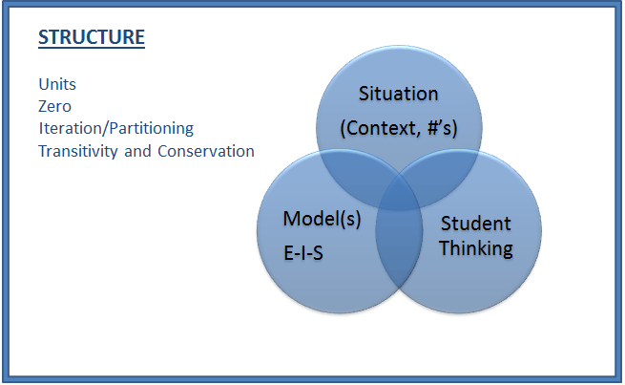
- To accurately measure physical attributes, no gaps or overlaps can occur during iterations of the unit of measure.
- Length is the measure from one point to another and requires a unit that is continuous.
- Measurements of length can be connected to the Base 10 number system. If an object is 10 or more units in length, a new unit of a single 10 can be used to describe the measurement. The process of renaming measurements as a collection of units of 10 and units of 1 (and examining many possible unit combinations) can be extended to many numbers.

Examples of An Informal Linear Measurement Situation
Situation: “Let’s measure the length of the tables in our classroom from one side to the other using cubes. Then let’s measure the length of the table using sticks of 10 cubes. Show these measurements in a drawing or use a number line. Now let’s compare the length across our classroom tables to the length across the hallway.”

Enactive and Iconic Models examples
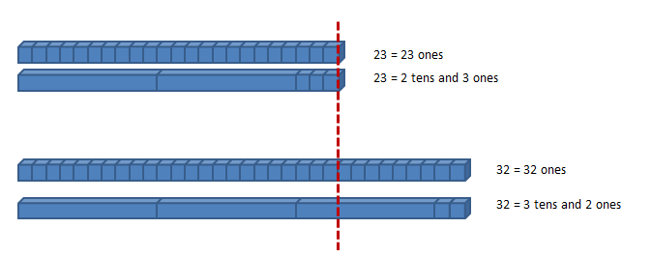

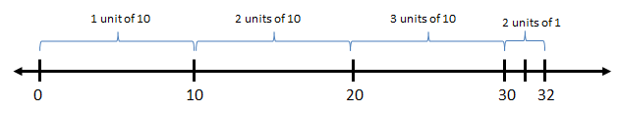

Symbolic Model example(s)
For this first unit, students are primarily using objects to practice linear measurement and making comparisons. Typically, they will transfer their physical measurements to drawings (e.g. informal bar graphs) or number lines. This will serve as a more permanent record of their work and begin to connect enactive and iconic representations as they can label their drawings and number lines. Students can also be encouraged to count measurements in units of 10 and units of 1 and describe these measurements in both oral and written language. For example, an object measuring 32 units in length can be described as “32 units in length” and also “3 units of ten and 2 units of one in length.”

Questions:
Which measurement was larger, the table or the hallway? [Skill]

(Using blocks as a measuring tool and unit) What is the length across the table? What is the length across the hallway? How much greater is the measurement of the (table/hallway) than the (hallway/table)? [Concept]

Measure the tallest person in your group (of 3-5 students). Find all of the objects in the classroom that are taller than this person using cubes. Use drawings or the number line to compare these measurements. [Reasoning/Communication]

Appendix A

Measurement and Data 1.MD
H. Measure lengths indirectly and by iterating length units.
1. Order three objects by length; compare the lengths of two objects indirectly by using a third object.
2. Express the length of an object as a whole number of length units, by laying multiple copies of a shorter object (the length unit) end to end; understand that the length measurement of an object is the number of same-size length units that span it with no gaps or overlaps. Limit to contexts where the object being measured is spanned by a whole number of length units with no gaps or overlaps.
J. Represent and interpret data.
4. Organize, represent, and interpret data with up to three categories; ask and answer questions about the total number of data points, how many in each category, and how many more or less are in one category than in another.

Number and Operations in Base Ten 1.NBT
E. Extend the counting sequence.
1. Count to 120, starting at any number less than 120. In this range, read and write numerals and represent a number of objects with a written numeral.

