Grade 1: Unit 1 Overview

Building number, counting and place value

Length of Unit: 3 – 4 weeks

Mathematical Practices (CCSS) |  | Grade Level Focus Areas | Grade Level Domains and Standards
- Make sense of problems and persevere in solving them.  - Reason abstractly and quantitatively.  - Construct viable arguments and critique the reasoning of others.  - Model with mathematics.  - Use appropriate tools strategically.  - Attend to precision.  - Look for and make use of structure.  - Look for and express regularity in repeated reasoning. |  | FA.1. Addition & Subtraction: Developing understanding of addition, subtraction, and strategies for addition and subtraction within 20  FA.2. Place Value Understanding: Developing understanding of whole number relationships and place value, including grouping in tens and ones | Major Domain: Number and Operations in Base Ten  Extend the counting sequence  Understand place value  Supporting Domains: Operations and Algebraic Thinking  Represent and solve problems involving addition and subtraction  Understand and apply properties of operations and the relationship between addition and subtraction
Structural Components (focusing lens) |  | Explanation (based on grade level and unit topic)
Unit/Unitizing |  | The unit of one and ten is used to count both forward and backwards.
Compose and Decompose |  | The ability to put objects together and then break them apart while still retaining numbers’ quantities and relative sizes.
Iterate and Partition |  | The ability to copy a unit of the same size or measure over and over again or split it up into equivalent units.
Relationship |  | Understanding how numbers or quantities are related to one another

Formative Assessment Questions, Tasks, or Examples
Skill/Procedure/Rote | Write the number 15.  Show me the number 24.  Count to 32 starting at 10 and then count backwards from 32 to 20.
Problem Solving | Solve joining and separating problem types with a focus on what aspect of the context indicates whether to add or subtract a set of numbers.  E.g., 12 bunnies sat on the grass. 7 more hopped over to them. How many bunnies are on the grass now? (Join Result Unknown)  E.g., 12 bunnies were sitting on the grass. If 7 bunnies hopped way, how many bunnies are left on the grass? (Separate Result Unknown)
Conceptual | How many tens do you need to make this number if you can only use tens and ones? What is another way to use tens and ones to compose the number?  Use a model to show the sum of 12 + 4.
Reasoning & Justification | A student claims the number thirteen is written as 31. Why would the student think this is correct? Use a model to explain why it should be written as 13 and not 31.

Models
Enactive | Cubes, objects, fingers, (tens frame, Rekenrek)
Iconic | Drawing of cubes, bar model, number line
Symbolic | Numbers, number sentences

Vocabulary
Domain Specific | Count, forward, backwards, more, less, add, subtract, number line, bar model, digit, decompose, and compose, (numbers 0 to 100), compare, part, whole, addition, subtraction, some, sum, difference
General | Count up (count on), count back, join, separate, equal (same as), less than, greater than, place value, units of ones and tens, order

Inclusion Topics
Patterns | Notice patterns visually and symbolically when counting forward and backwards (starting at 0).
Fluency Development | Students should count forward and back from any starting number 0-120 (e.g. “Start counting back from 39 and stop when I tell you to”).

Description of Key Ideas for Learning Goals
There are four units in Grade 1 that focus on number, counting, number operations, and place value. Each unit builds specific skills within the topic of number. In this first unit on number the focus is on counting forward and backwards; adding and subtracting using joining and separating problem types (with numbers at least up to 20); representing the different situations using enactive iconic and symbolic models; and building place value understanding of the teen numbers. The key ideas for this unit are:

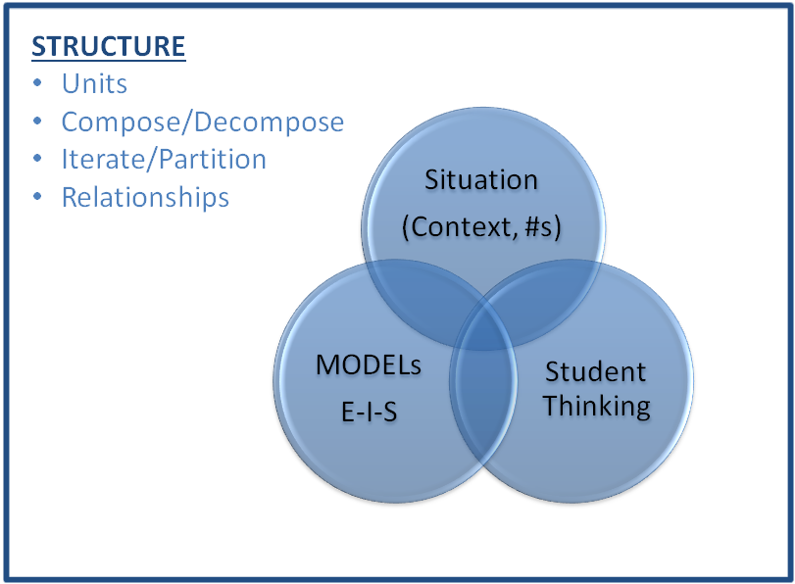
- The quantity one is the unit size of one or a measure of one.
- The quantity ten is its own unit, which is composed of ten units of size one.
- Students count numbers forward and backwards, counting each object one time in sequence (one-to-one to correspondence).
- When counting a group or set of objects, the last number counted represents the total amount of objects (cardinality). This also includes the concept of hierarchical inclusion (e.g. 3 “includes both 2 and 1).
- A number can indicate a position in a series (ordinality).

Examples of Models and Situations

Situations:
Note: The additional number sets provided after each problem are intended to replace the original numbers in the problem to increase the problem’s difficulty and to offer more place value connections. Some of the extension number sets will be above grade level in difficulty and can be reserved for only students needing additional rigor.

Jack had 8 toy cars. Jack was given 5 more toy cars. How many toy cars does Jack have now? (8, 15) (17, 9) (19, 13) [Join Result Unknown]

Jack had 8 toy cars. Jack was given some more toy cars. Now Jack has 13 toy cars. How many toy cars was Jack given? (12, 17) (7, 17) (3, 19) [Join Change Unknown]

Jack had 8 toy cars. Jack gave 3 to a friend. How many toy cars does he have now? (15, 12) (17, 9), (18, 4) [Separate Result Unknown]

Jack had 8 toy cars. He gave some to a friend. Now he has 5 toy cars. How many did he give away? (16, 12), (14, 8), (19, 4) [Separate Change Unknown]

Enactive Model (Toy cars example)
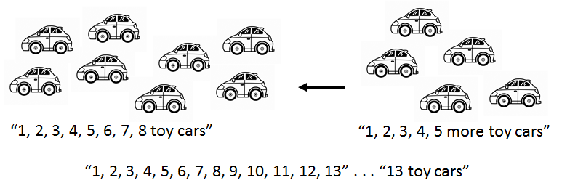

Now, line the cars up in a row or one after the other. Count them again. [Skill]
How many more cars do you need to have 20 cars? [Problem solving]

Iconic Model (Number line and bar model examples)
Create a number line to represent how you solved the problem (above). [Concept]
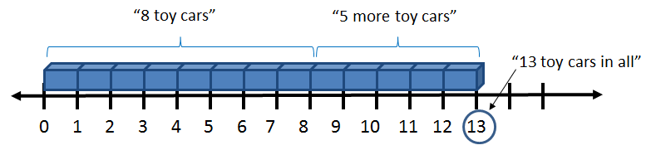
There are two 5’s in the diagram above. Explain what each of the 5’s mean? [Reasoning and Justification]
How many more toy cars do you need in order to have 15 toy cars? [Problem solving]

Situation: Jack has 8 toy cars. Jack was given some more toy cars. Now Jack has 13 toy cars. How many toy cars was Jack given? Represent this situation using the number line. (12, 17) (7, 17) (3, 19) [Join Change Unknown]
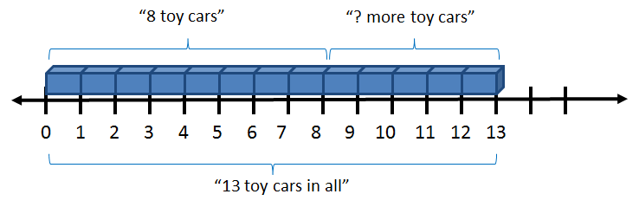
Situation: Jack has 7 toy cars. Fran says that if you gave 4 toys cars to one friend and 3 toy cars to another, then you would have 1 toy car left. Explain whether you think this is correct or not. Show how you know using a model. [Reasoning and Justification]

Symbolic Model
Initially, students start to place numbers with their number line model (above). They should use numerals and practice writing them. Students can then be asked to write number sentences to match the story problem and to match how they solve the problem.
In the first problem with Jack, the number sentence that matches the story is 8 + 5 = □.
The number sentences that match how they solved the problem might be one of the following:
Counting all: 1 + 1 + 1 + 1 + 1 + 1 + 1 + 1 + 1 + 1 + 1 + 1 + 1 = 13
Counting on: 8 + 1 + 1 + 1 + 1 + 1 = 13
Derived fact strategy: 8 + 2 = 10 10 + 3 = 13
Fact: 8 + 5 = 13

Place Value Situations
This unit should emphasize place value over any other content. The previous examples of problem solving tasks are provided to show the way in which students should model any problem solving situations. These skills and concepts should be review from previous learning in kindergarten. To model place value tasks (the major focus of this unit) students should use cubes, the bar model and numbers to represent quantities using units of one and units of ten. Ask students about place value in relation to the ones and tens units. For example, the number 12 represents 12 units of size 1 or 1 unit of size 10 and 2 units of size one. This idea is represented below both iconically and symbolically. Have students create representations for the numbers 10 through 20.
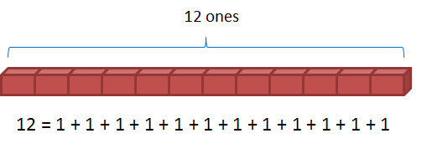
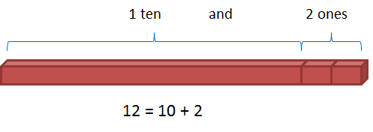

Patterns: Ask students to look for patterns by counting on from any number, n and 10 + n (e.g., 3 and 13 or 6 and 16). One activity would be for students to either build with cubes or with a bar model the matching numbers 0 and 10, 1 and 11, 2 and 12, . . . 10 and 20.

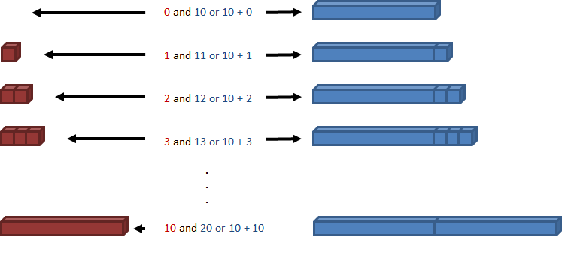

Appendix A

Number and Operations in Base Ten 1.NBT
E. Extend the counting sequence.
1. Count to 120, starting at any number less than 120. In this range, read and write numerals and represent a number of objects with a written numeral.
F. Understand place value.
2. Understand that the two digits of a two-digit number represent amounts of tens and ones. Understand the following as special cases:
a. 10 can be thought of as a bundle of ten ones — called a “ten.”
b. The numbers from 11 to 19 are composed of a ten and one, two, three, four, five, six, seven, eight, or nine ones.
c. The numbers 10, 20, 30, 40, 50, 60, 70, 80, 90 refer to one, two, three, four, five, six, seven, eight, or nine tens (and 0 ones).
3. Compare two two-digit numbers based on meanings of the tens and ones digits, recording the results of comparisons with the symbols >, =, and <.

Operations and Algebraic Thinking 1.OA
A. Represent and solve problems involving addition and subtraction.
1. Use addition and subtraction within 20 to solve word problems involving situations of adding to, taking from, putting together, taking apart, and comparing, with unknowns in all positions, e.g., by using objects, drawings, and equations with a symbol for the unknown number to represent the problem.
2. Solve word problems that call for addition of three whole numbers whose sum is less than or equal to 20, e.g., by using objects, drawings, and equations with a symbol for the unknown number to represent the problem.
B. Understand and apply properties of operations and the relationship between addition and subtraction.
3. Apply properties of operations as strategies to add and subtract. Examples: If 8 + 3 = 11 is known, then 3 + 8 = 11 is also known. (Commutative property of addition.) To add 2 + 6 + 4, the second two numbers can be added to make a ten, so 2 + 6 + 4 = 2 + 10 = 12. (Associative property of addition.)
4. Understand subtraction as an unknown-addend problem. For example, subtract 10 – 8 by finding the number that makes 10 when added to 8.

